 

| **FPT-APTECH COMPUTER EDUCATION** |
| --- |
| eProject Document |
| Netflixo |
|  |
| | **<Group Name>** | | | --- | --- | | **Group Member** | Nghiêm Tiến Anh TH2208053  Đinh Doanh Việt TH2209073  Trịnh Đình Quốc TH2209208 | | **Instructor** | Nguyễn Tuân | | **Batch** | FPT Aptech Hanoi | | **Semester** | 4 | |
|  |

| - Hanoi, 10/2024 |
| --- |

<This is the template document. Replace any text in <> with your text. When you are done, there should be no <> or text surrounded by <> in this document. Remember, this purpose of this document is to be useful: not just work to get a grade.>

**1. Introduction** **4**

**2. Problem Definition** **4**

2.1. Problem Abstraction 4

2.2. The Current System 4

2.3. The Proposed System 4

2.4. Boundaries of the System 4

2.5. Development Environment 4

**3. Requirements and Business Flow** **6**

3.1. Customer Requirement Specification 6

3.2. Activity Diagram 6

3.3. Use Case Diagram 6

3.4. Use Case Specification 6

3.5. Other Concerns<Optional> 7

**4. Design** **8**

4.1. System Architecture 8

4.2. Class Diagram 8

4.3. Class Diagram Explanation 8

4.4. Sequence Diagram (Optional) 8

4.5. Collaboration Diagram (Optional) 8

4.6. State Diagram (Optional) 8

4.7. Entity Relationship Diagram 8

4.8. Database Design 8

4.9. Algorithms (optional) 9

4.10. Others (optional) 9

**5. System Prototype** **10**

**6. Management and Project Planning** **11**

6.1. Management Approach 11

6.2. Project Plan 11

6.3. Task Sheet 11

6.4. Meeting Minutes (Optional) 11

**7. Checklists** **12**

7.1. Check List of Validation 12

7.2. Submission Checklist 12

**8. Screenshots** **12**

**9. Coding Convention** **12**

**10. Other Concerns<Optional>** **12**

**Appendix** **13**

Glossary [Optional] 13

References [Optional] 13

Others<Optional> 13

# Introduction

This document is prepared to provide an overview of the development project for the Netflixo movie streaming website. It is organized into several sections, each presenting different aspects of the project, from problem definition to system design, project management, and technical requirements.

**The content of the document includes:**

* **Problem Definition:** Presents the current issues in the field of online movie streaming and the reasons for the formation of the Netflixo project.
* **Requirements and Business Flowchart:** Provides detailed information about customer requirements, activity diagrams, and Use Cases to illustrate the processes and functions of the system.
* **Design:** Describes the system architecture, class diagrams, database design, and other essential elements needed for system construction.
* **System Prototype:** Presents the test models and user interfaces of the system.
* **Project Management and Planning:** Outlines the management methods, project plan, and related task tables.
* **Checklists:** Includes necessary checklists to ensure that the project meets quality requirements.
* **Screenshots and Coding Standards:** Provides illustrative images and guidelines on coding standards used in the project.
* **Appendices:** Offers additional terminology and reference materials, if necessary.

This document aims to help readers better understand the Netflixo project, from theory to practice, and provide the necessary information to evaluate the effectiveness of the system.

# Problem Definition

## Problem Abstraction

The Netflixo project was conceived to address challenges in the online movie streaming domain, where users often struggle to find and access content that aligns with their personal preferences. With the rapid advancement of technology, the demand for online entertainment is increasing, and consumers need an efficient platform to easily access movies and TV shows.

**The main issues that this project aims to tackle include:**

* **Difficulty in Content Search:** Users encounter challenges in searching for and categorizing movies by genre, release year, or popularity.
* **Lack of Personalization:** Many existing platforms do not offer movie recommendations based on user preferences and viewing history, leading to a suboptimal viewing experience.
* **User Interface Issues:** Several current movie streaming websites lack a friendly and easy-to-use interface, making it difficult for users to navigate and find content.
* **Quality and Reliability Concerns:** Users are also concerned about the quality of videos and the reliability of online services, especially regarding streaming stability.

The Netflixo project aims to develop an online platform that addresses these issues, providing a better movie-watching experience for users through modern technology and personalized features.

## The Current System

According to the Customer's Requirement Statement, the current movie streaming systems in the market have several limitations that hinder the overall user experience and service efficiency. Existing platforms often lack an intuitive interface, making it difficult for users to navigate through movies and series. This complexity is particularly challenging for users who may not be tech-savvy, leading to frustration and dissatisfaction.

Another major issue highlighted is the absence of personalized recommendations. Most current platforms do not fully utilize user data to generate suggestions that align with individual viewing preferences, resulting in irrelevant content recommendations that fail to engage the user effectively.

Security is also a significant concern in the current systems. Users today expect high standards of data privacy, but existing platforms sometimes lack robust security measures, leaving personal information and viewing histories vulnerable to unauthorized access.

Finally, scalability issues are common in the current solutions, especially during peak times when high user traffic causes slow loading times, buffering, and crashes. These limitations underline the need for a more resilient, user-friendly, and secure system, which Netflixo aims to provide to improve user satisfaction and deliver a superior streaming experience.

## The Proposed System

The proposed system, Netflixo, is designed to provide an intuitive and efficient online movie streaming platform that caters to the diverse needs of users. This system aims to enhance the overall viewing experience by offering a wide range of features that prioritize user preferences and ease of access. Key components of the proposed system include:

* **User-Friendly Interface:** The platform will feature a clean and modern interface that allows users to easily navigate through various categories and find their desired content without difficulty.
* **Advanced Search Functionality:** Netflixo will implement a robust search feature that enables users to filter movies by genre, release year, rating, and more, ensuring quick access to relevant content.
* **Personalized Recommendations:** The system will utilize algorithms to analyze users' viewing habits and preferences, providing tailored movie suggestions to enhance user engagement and satisfaction.
* **High-Quality Streaming:** Netflixo will ensure a reliable streaming experience with high-definition video quality, minimizing buffering and maximizing user satisfaction.
* **Secure User Accounts:** The system will include secure account management features, allowing users to create and manage their profiles while ensuring the protection of personal data.
* **Mobile Responsiveness:** The platform will be optimized for both desktop and mobile devices, ensuring that users can enjoy a seamless viewing experience across various devices.
* Overall, the proposed Netflixo system aims to revolutionize the online movie streaming experience by addressing current challenges and providing a user-centric platform that meets the evolving demands of viewers.

## Boundaries of the System

The boundaries of the Netflixo system define its scope, including both in-scope and out-of-scope features:

**In-Scope Features:**

* **User Registration and Authentication:** Secure account creation and login.
* **Movie Database:** A comprehensive collection of movies with details.
* **Search and Filter Options:** Ability to search movies by various criteria.
* **Personalized Recommendations:** Tailored movie suggestions based on user preferences.
* **Watchlist and Favorites:** Functionality to save and manage favorite movies.
* **Streaming Functionality:** High-quality streaming of on-demand content.
* **User Interface Design:** A responsive and intuitive interface for easy navigation.

**Out-of-Scope Features:**

* **Live Streaming:** No live events or shows will be included.
* **Social Media Integration:** No sharing features for social platforms.
* **Offline Viewing:** Downloading movies for offline access is not included.
* **Multi-Language Support:** The initial version will focus on English only.
* **Third-Party Advertisements:** No advertisements will be included in the initial version.

## Development Environment

The development environment for the Netflixo project is designed to support efficient and effective software development. It includes both software and hardware requirements to ensure a smooth development process.

**Software Requirements:**

**Development Framework:**

* **Node.js:** A JavaScript runtime for building scalable network applications.
* **Express.js:** A web application framework for Node.js to simplify server-side development.
* **Spring Boot:** A framework for building Java-based web applications, which can be used for creating the backend services.

**Database:**

* **MongoDB:** A NoSQL database to store movie data and user information.

**Frontend Technologies:**

* **HTML/CSS:** For structuring and styling the user interface.
* **JavaScript:** For interactive and dynamic web functionality.
* **React.js (optional):** A JavaScript library for building user interfaces, enhancing the responsiveness of the application.
* **Tailwind CSS:** A utility-first CSS framework for rapidly designing custom user interfaces.

**Development Tools:**

* **Visual Studio Code:** A code editor for writing and managing the codebase.
* **Postman:** For testing APIs and ensuring correct data communication between client and server.
* **Git:** Version control system for tracking changes in the codebase.
* **Visual Studio 2022:** An IDE for developing .NET applications, applicable if .NET technologies are integrated into the project.
* **IntelliJ IDEA:** An integrated development environment (IDE) for Java, which is useful for working with Spring Boot.

**Hosting and Deployment:**

* Firebase Hosting: For deploying the frontend of the application.

### Hardware Requirements:

**Development Machine:**

* **Processor:** Minimum dual-core processor.
* **RAM:** At least 8 GB of RAM to support development tools and multitasking.
* **Storage:** Minimum 256 GB SSD for faster data access and storage of project files.
* **Operating System:** Windows, macOS, or Linux compatible with development tools.

**Testing Devices:**

* **Mobile Devices:** Smartphones and tablets with different operating systems (iOS and Android) for testing the responsiveness of the web application.
* **Desktop Computers:** Various configurations to ensure compatibility across different systems.

**Conclusion**

The development environment outlined above provides the necessary tools and resources for building a robust online movie streaming platform. It is designed to facilitate collaboration, testing, and deployment while ensuring a high-quality user experience.

# Requirements and Business Flow

In this section, we will outline the requirements developed for the Netflixo project, along with an overview of the business flow. The goal is to provide useful information, only including enough details (requirements, diagrams) to support the implementation of the software. The focus will be on the “non-obvious” aspects.

**Requirements**

The following requirements have been identified for the Netflixo platform:

**User Authentication**

* Users must be able to register and log in using their email and password.
* Passwords must be securely stored and encrypted.

**Content Management**

* Admins should be able to add, edit, or delete movie entries from the database.
* Movies should include details such as title, genre, description, release date, and ratings.

**Subscription Management**

* Users must be able to choose from multiple subscription plans (weekly, monthly, yearly).
* Payment processing should be handled through PayPal.

**Search and Filtering**

* Users should be able to search for movies by title, genre, or ratings.
* The system must provide filtering options to narrow down search results.

**Personalization**

* The platform should offer movie recommendations based on user viewing history.
* Users should be able to maintain a watchlist of movies they want to see.

**User Interaction**

* Users should have the ability to leave reviews and ratings for movies.
* The system should display user ratings and reviews for each movie.

#### Business Flow

To illustrate the business flow, the following activity diagram outlines the key processes involved in the user experience on the Netflixo platform:

* **User Registration and Login**
* **Subscription Selection and Payment**
* **Movie Browsing and Searching**
* **Viewing Details and Adding to Watchlist**
* **Reviewing and Rating Movies**

You can create an activity diagram that visually represents these steps, showing how users interact with the system and the flow of actions between different components.

#### Example Activity Diagram

Below is a simple outline of how the activity diagram might look:

**Start**

**User Registration/Login**

* + If registered, proceed to login.
  + If not registered, create an account.

**Select Subscription Plan**

* + Choose plan type.
  + Proceed to payment.

**Payment Processing**

* + Confirm payment.
  + If successful, activate subscription.

**Browse Movies**

* + Search by title, genre, or rating.
  + Filter results.

**View Movie Details**

* + Add movie to watchlist.
  + Leave a review or rating.

**End**

## Customer Requirement Specification

The customer requirements for the Netflixo project

**User Management:**

* Users must register
* Support for secure login, logout, and password recovery.

**Movie Database Management:**

* Admins can add, edit, and delete movie entries.
* Each movie must include a title, genre, description, relea

**Search and Filtering:**

* Users can search for movies by title, genre, and release year.
* Availability of filtering options by ratings and duration.

**Watchlist Feature:**

* Users can add and remove movies from their watchlist.

**Subscription Plans:**

* Offer subscription options for weekly, monthly, and yearly access to movies.
* Support international payments through PayPal.

**Streaming Quality:**

* Ensure high-quality streaming with minimal buffering.

**User Interface:**

* The application must have a responsive and user-friendly interface.

## Activity Diagram

**Activity Diagram for User Registration and Subscription Process**

**Description**

The activity diagram below illustrates the key business processes involved in user registration and managing subscriptions in the Netflixo system.

**Activity Diagram**

**User Registration Process:**

* Start
* User inputs required information (username, password, email).
* System validates user information.
* If valid, create user account.
* If invalid, return error message.
* End

**User Login Process:**

* Start
* User inputs login credentials (username, password).
* System validates credentials.
* If valid, allow access to the platform.
* If invalid, return error message.
* End

**Subscription Management:**

* Start
* User selects subscription plan (weekly, monthly, yearly).
* User proceeds to payment via PayPal.
* System processes payment.
* If payment is successful, update user subscription status.
* If payment fails, return error message.
* End

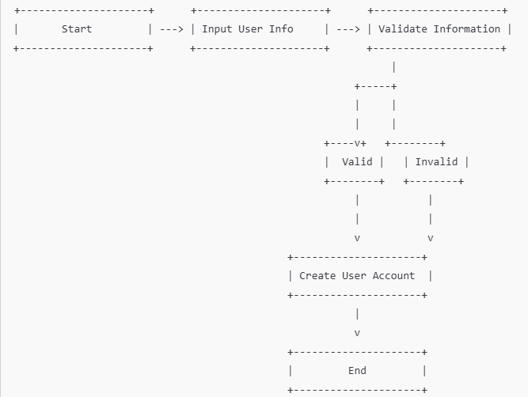

## Use Case Diagram

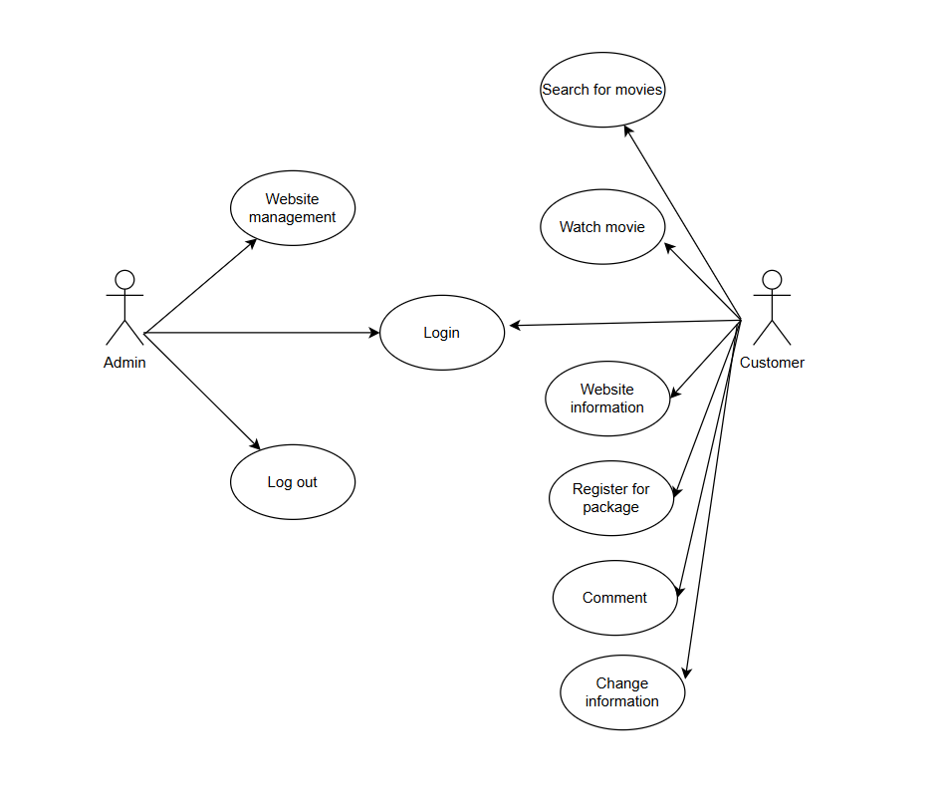

## Use Case Specification

<Write down all non-trivial use cases. This should reflect what you get when your team does the system analysis. Use the template to write the detailed specification for use cases>

<Use case template:

| **USE CASE SPECIFICATION** | | | | |
| --- | --- | --- | --- | --- |
| **Use-case No.** | UC001 | **Use-case Version** | | 1.0 |
| **Use-case Name** | Netflixo | | | |
| **Author** | Project Team Members | | | |
| **Date** | 27/10/2024 | **Priority** | High | |
| **Actor:** User, System  **Summary:**  Users can register a new account on the system to access movie streaming services.  **Goal:**  The goal of this use case is to allow users to successfully create an account and gain access to the system's functionalities.  **Triggers**  The user selects the registration option on the login page.  **Preconditions:**  The user does not have an account on the system.  The user has an internet connection.  **Post Conditions:**  The user account is created and stored in the database.  The user can log in to the system using the newly created account information.  **Main Success Scenario:**  The user accesses the registration page.  The user enters the required information (username, password, email).  The system validates the user information.  If the information is valid, the system creates the account and stores the information in the database.  The system notifies that the account has been successfully created.  The user is redirected to the login page.    **Alternative Scenario:**  **A1:** If the information is invalid (e.g., the username already exists), the system displays an error message and prompts the user to re-enter the information.condition  **A2:** If the user decides to cancel the registration process, they can return to the login page without any changes.  **Exceptions:**  If there is an error in storing the account information (e.g., database error), the system displays an error message and prompts the user to try again.  **Relationships:**  Linked to Use Case UC002 (User Login) - After successful registration, the user can log in to the system.    **Business Rules:**  Each user must have a unique username.  The password must meet length and complexity requirements. | | | | |

## Other Concerns<Optional>

**Other Concerns**

**User Privacy and Data Security:** It is essential to ensure that user data, including personal information and payment details, are stored securely and comply with relevant data protection regulations (e.g., GDPR).

**Payment Processing:** The integration of international PayPal payment processing should be secure and reliable. There must be clear procedures for handling payment failures or disputes.

**User Experience:** The interface should be user-friendly, providing easy navigation and quick access to movies. Consideration should be given to users of varying technical abilities.

**Customer Support:** A robust customer support system should be in place to assist users with account issues, payment problems, and technical difficulties.

**Feedback Mechanism:** Establish a method for users to provide feedback on the service, which can help in making iterative improvements.

**Mobile Compatibility:** As many users may access the platform via mobile devices, the website should be responsive and optimized for various screen sizes.

# Design

This section outlines the system design for Netflixo, providing a structured overview of the system architecture and component relationships. The design is organized into modules, each responsible for a different aspect of functionality, from user management to movie streaming, payments, and content recommendations.

* **Frontend**: Built with HTML, CSS, JavaScript (optional React), for user interactions like browsing and managing subscriptions.
* **Backend**: Developed with Node.js and Express to handle user management, movie recommendations, and account processing.
* **Database**: MongoDB stores data on users, movies, subscriptions, payments, and watch history.

**Core Components**:

* **User Management**: Manages user accounts and authentication.
* **Movie Streaming**: Handles movie catalog, classifications, and recommendations.
* **Subscription & Payment**: Manages subscription plans, PayPal payments, and status updates.
* **History & Recommendations**: Tracks user history to suggest content.

**Data Flow**:

* Users register and subscribe via PayPal.
* Subscription grants access to stream movies.
* The system personalizes recommendations using user watch history.

**Developer Guidelines**:

* Keep code modular and well-documented.
* Optimize MongoDB for high-traffic queries.
* Ensure error handling and logging, especially for payments and external API interactions.

## System Architecture

* 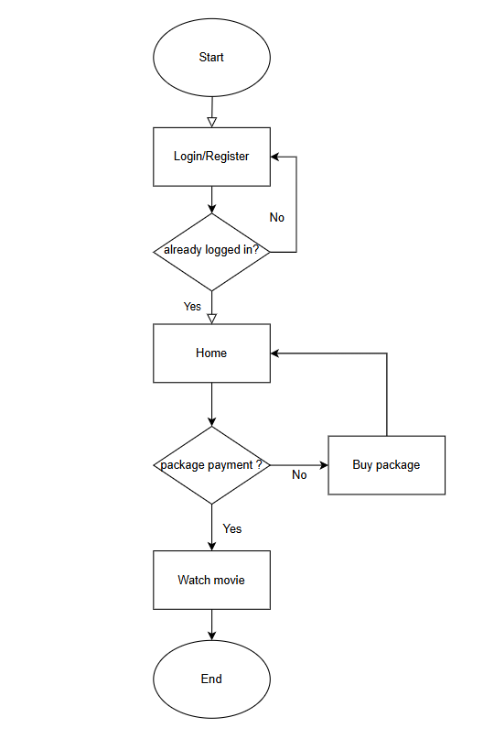

## Class Diagram

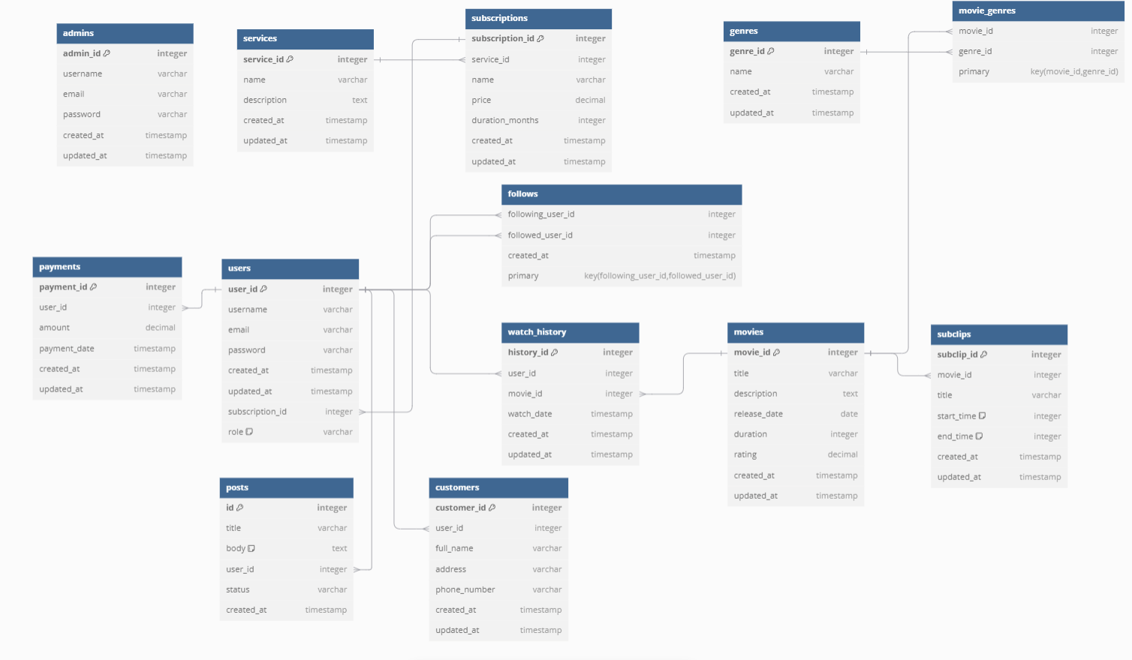

## Class Diagram Explanation

**Explanation of Key Classes:**

* **User**: Represents the core user entity with essential attributes like username, email, and subscription status. Relationships connect this class to Subscription (indicating which plan the user is subscribed to) and WatchHistory, allowing tracking of watched content.
* **Subscription**: This class details the subscription plans available, such as weekly, monthly, or yearly, including information about pricing and duration. Users interact with this class to determine their access to the content.
* **Movie**: Stores detailed information about individual movies, including title, genre, and ratings. This class is associated with Category to group movies by genres and Review to capture user feedback and ratings for each movie.
* **Category**: Contains movie genres and categories, enabling filtering and searching by genre. It has a one-to-many relationship with Movie, allowing multiple movies to fall under a single category.
* **Payment**: Manages transactions, including payment amount and date, facilitating integration with external payment providers like PayPal for subscription purchases. Each Payment instance is linked to a specific user and subscription.

## Sequence Diagram (Optional)

**User Registration and Authentication**

**Flow:**

* User accesses the registration form and enters details.
* Backend validates information and checks for duplicates in the Database.
* If valid, a new user account is created.
* Confirmation is sent, and user is redirected to the login page.

**Subscription Purchase and Payment Processing**

**Flow**:

* User selects a subscription plan.
* Backend initiates payment via PayPal API.
* Upon payment confirmation, the subscription is activated in the Database.

## Collaboration Diagram (Optional)

Below are concise collaboration flows for key interactions in the Netflixo system, focusing on user registration, subscription purchase, and movie streaming.

**User Registration**

**Actors**: User, UI Component, Authentication Service, Database

**Flow**:

* **User** interacts with the **UI Component** to input registration details.
* **UI Component** sends data to **Authentication Service**.
* **Authentication Service** checks the **Database** for duplicates and, if clear, creates a new user entry.
* **Authentication Service** confirms success to **UI Component**, which notifies the **User**.

**Subscription Purchase**

**Actors: User, UI Component, Payment Service, Database.**

**Flow:**

* **User** selects a plan through **UI Component**.
* **UI Component** triggers **Payment Service** for transaction.
* **Payment Service** verifies payment and updates **Database** for subscription status.
* **UI Component** informs **User** of successful subscription.

## State Diagram (Optional)

The state diagram visually represents the various states of an object in the Netflixo system and the transitions between those states. Below are some key state diagrams that you might want to consider for your project:

#### User Account State Diagram

**States:**

**Registered:** The user has successfully registered an account.

**Logged In:** The user is authenticated and can access all functionalities.

**Logged Out:** The user is not authenticated.

**Inactive:** The account is deactivated or suspended.

**Transitions:**

From **Registered** to **Logged In** upon successful login.

From **Logged In** to **Logged Out** upon logout.

From **Logged In** to **Inactive** when the account is suspended.

From **Inactive** to **Logged Out** upon account deactivation.

#### Movie Status State Diagram

**States:**

**Available:** The movie is available for streaming.

**Pending:** The movie is awaiting approval or processing.

**Unavailable:** The movie is not available for viewing.

**Transitions:**

From **Pending** to **Available** upon approval.

From **Available** to **Unavailable** if removed from the catalog.

From **Unavailable** to **Available** if the movie is reinstated.

#### Subscription State Diagram

**States:**

**Active:** The user's subscription is active.

**Expired:** The user's subscription has expired.

**Canceled:** The user has canceled their subscription.

**Transitions:**

From **Active** to **Expired** when the subscription period ends.

From **Active** to **Canceled** when the user cancels their subscription.

From **Expired** to **Active** upon renewal.

**Example State Diagram for User Account**

[Registered] -- (Login) --> [Logged In]

[Logged In] -- (Logout) --> [Logged Out]

[Logged In] -- (Suspend) --> [Inactive]

[Inactive] -- (Deactivate) --> [Logged Out]

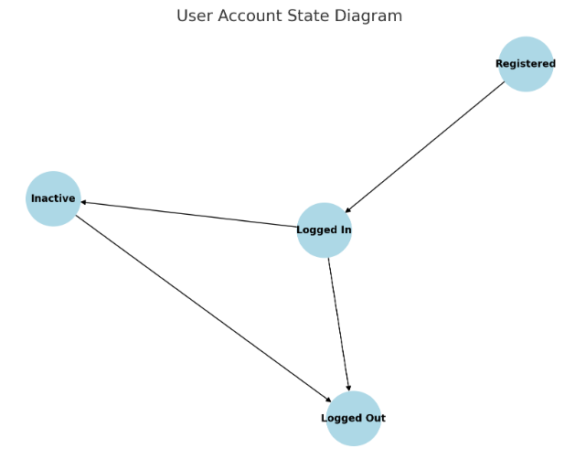

## Entity Relationship Diagram

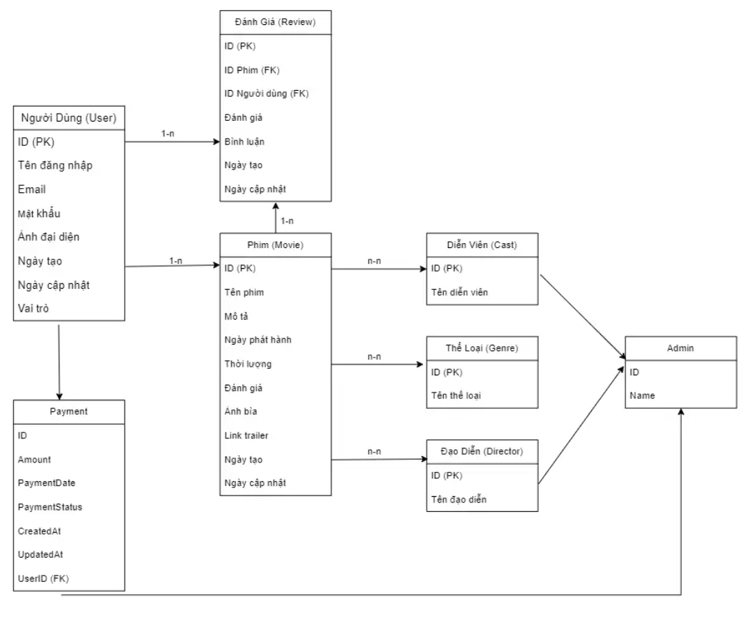

## Database Design



## Algorithms (optional)

Here are some common algorithms I use for website development:

**Movie Search Algorithm:** Use binary search or linear search to quickly find movies in the list.

**Pagination Algorithm:** Divide the list of movies into pages to improve performance and user experience.

**Ranking Algorithm:** Calculate average ratings and sort movies by their ratings to display the most outstanding films.

**State Management:** Use Redux or Context API to manage the application state, such as storing user information or favorite movies.

**Filtering Algorithm:** Allow users to filter movies by genre, release year, or rating.

## Others (optional)

This is the website diagram to accurately reflect the theme of the website.



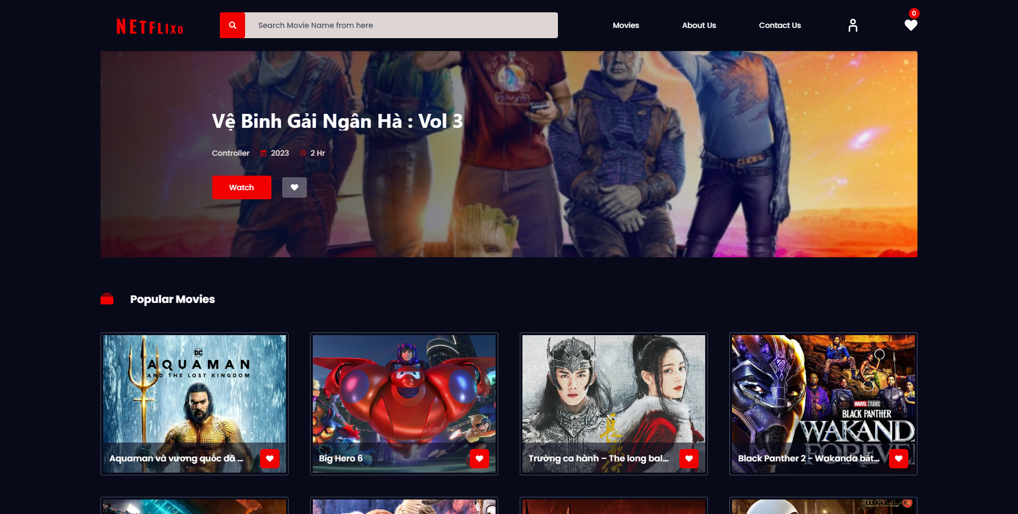

# System Prototype

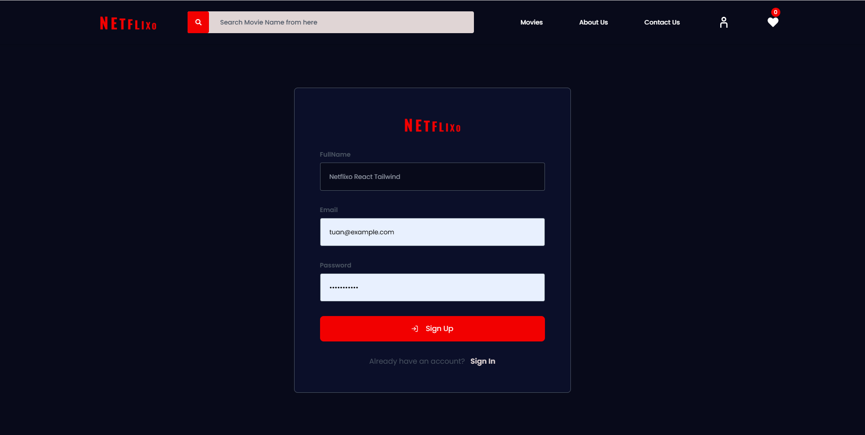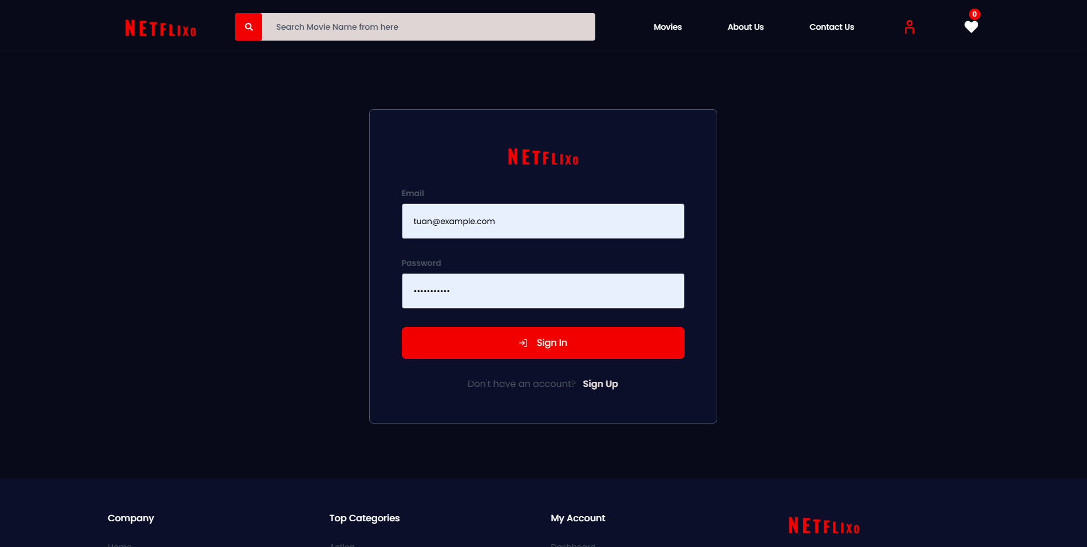



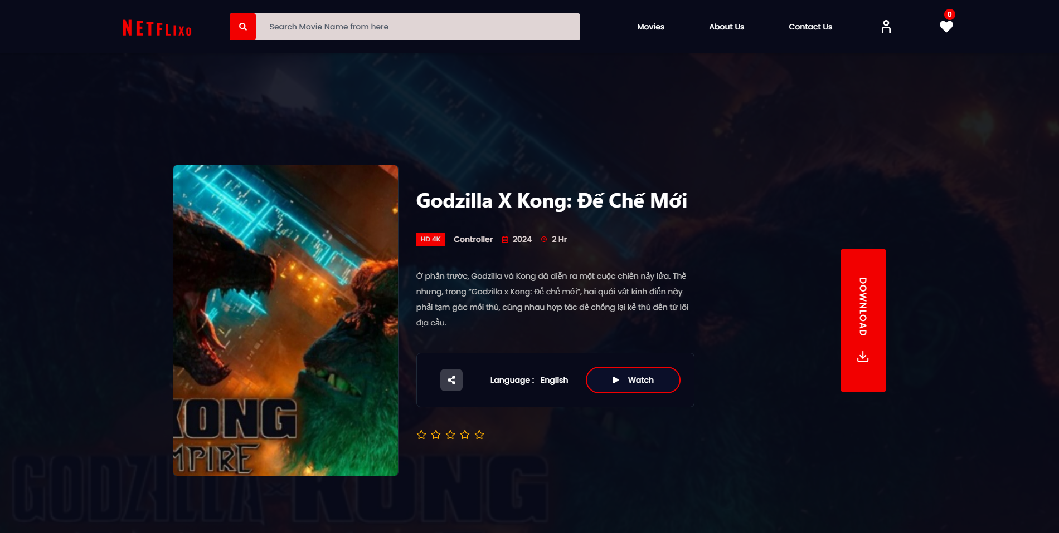

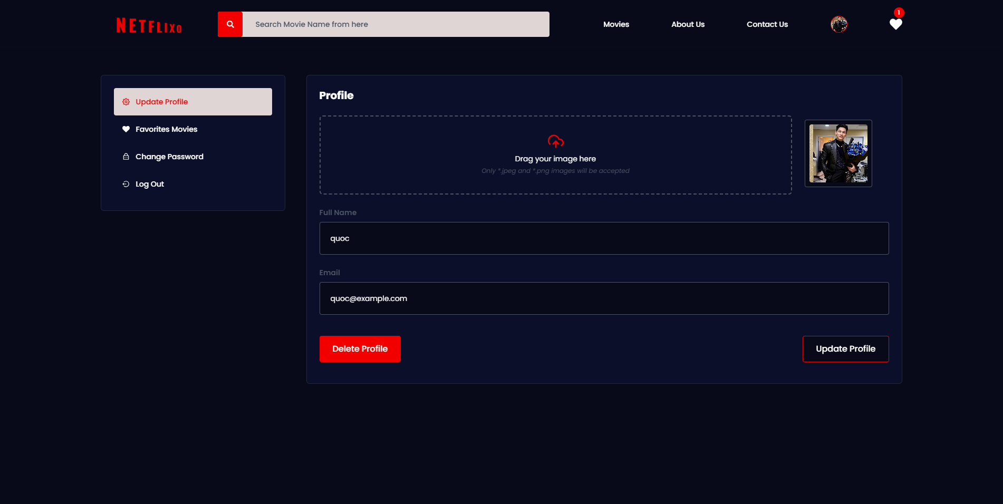

# Management and Project Planning

## Management Approach

< Briefly describe the management approach that your team selects. Is your team self-managed or managed by one leader? How do you assign tasks to team members? How often do you meet? What do you do during meetings? Etc.>

* I manage the project by assigning each team member a specific task and reaching a consensus on the project approach.

My team has a leader.

The team leader assigns tasks based on each member's strengths to maximize their abilities.

My team meets every two days.

## Project Plan

[Netflixo](https://docs.google.com/spreadsheets/d/1R4DeYYcbFswGvoYhiRswBGrYMrfV1dR7RbHrDsoAEFM/edit?usp=sharing)

## Task Sheet

### Project Manager

* Responsible for planning and monitoring the project's progress.
* Assign tasks to each team member.
* Organize regular meetings to assess progress and resolve arising issues.

### Frontend Developer

* Design the user interface for the movie website.
* Use HTML, CSS, and JavaScript to develop interactive features.

### Backend Developer

* Build the server and database system to store information about movies, users, and reviews.
* Create APIs that allow frontend and backend communication.
* Ensure the security of user data and the system.
* Ensure the website works well on various devices (responsive design).

### UI/UX Designer

-Research and create attractive and user-friendly user interface designs.

-Conduct user testing to gather feedback and improve user experience.

-I will check each member's work once a week to monitor their progress and provide assistance as needed.

-Ensure that design elements are consistent with the theme of the movie website.

## Meeting Minutes (Optional)

**Meeting Date:** [October 27, 2024]  
**Time:** [08:00 AM] - [12:00 PM]  
**Location:** [8a Tôn Thất Thuyết]  
**Attendees:** Đinh Doanh Việt, Trịnh Đình Quốc, Nghiêm Tiến Anh

**Meeting Agenda:  
Main Topic:** Project Progress Update

* Completed the user interface design.
* Assigned tasks to each team member.
* User Feedback:
  + Collected feedback from user testing and proposed improvements.

**Next Tasks:**

* Finalize design elements consistent with the movie theme.

**Conclusion:**

* All completed according to the team leader's requirements.

# Checklists

## Check List of Validation

### User Interface:

* Ensure consistency in colors and typography.
* Check the usability of buttons and links.

### Functionality:

* Verify the search functionality.
* Test the user login/signup features.

### Compatibility:

* Test on different browsers (Chrome, Firefox, Safari).
* Ensure good performance on mobile devices.

### Performance:

* Test page loading speed.
* Evaluate response time of features.

### User Testing:

* Collect feedback from users.
* Make adjustments based on feedback.

## Submission Checklist

### User Interface:

* Ensure consistency in colors and typography.
* Check the usability of buttons and links.

### Functionality:

* Verify the search functionality.
* Test the user login/signup features.

### Compatibility:

* Test on different browsers (Chrome, Firefox, Safari).
* Ensure good performance on mobile devices.

### Performance:

* Test page loading speed.
* Evaluate response time of features.

### User Testing:

* Collect feedback from users.
* Make adjustments based on feedback.

### How to Use:

This checklist is used to track tasks that need to be completed during the development of the website. As each item is checked and completed, the boxes will be marked, ensuring that all important aspects have been addressed.

# Screenshots

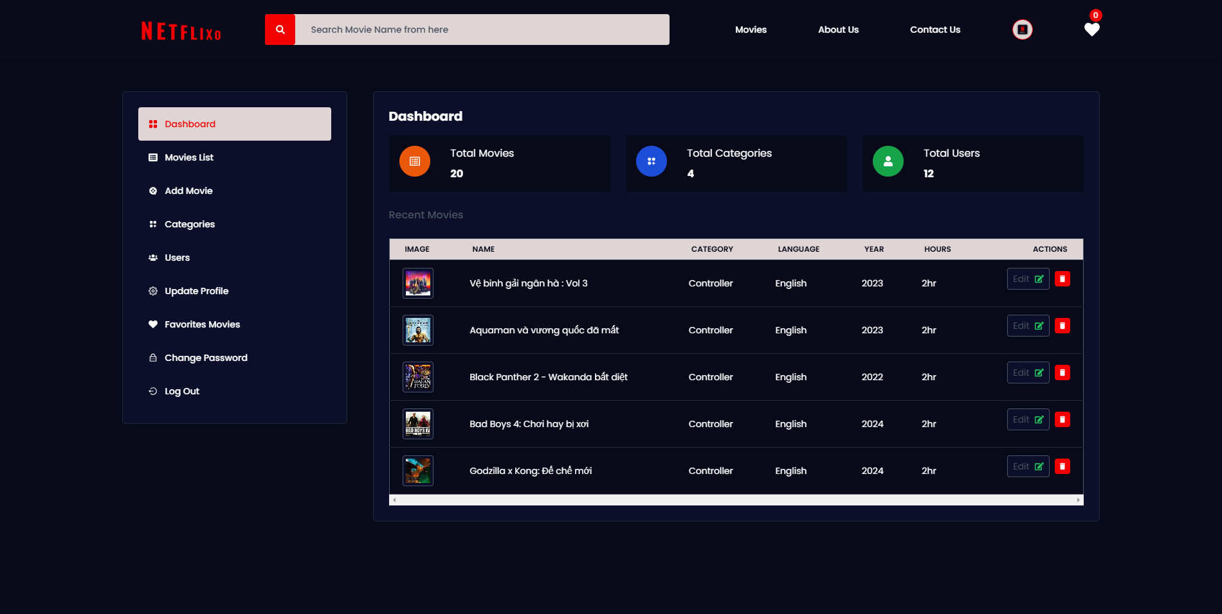

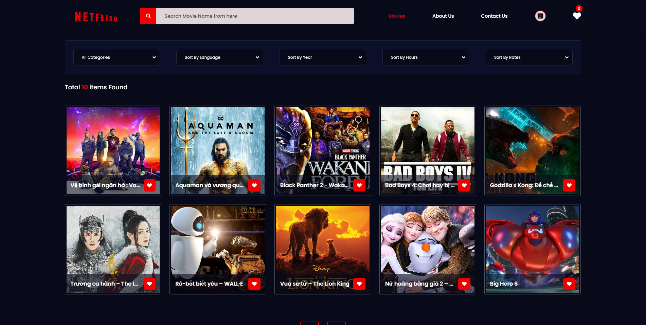

# Coding Convention

This section outlines the coding conventions that the development team for the Netflixo project will follow to ensure consistency and maintainability in the codebase. Below are the main coding standards that we will apply:

**General Rules**

* **Syntax**: Use correct and clear syntax for all programming languages utilized in the project.
* **Variable and Function Names**: Use camelCase for variable and function names, and PascalCase for class names.

**Code Formatting**

* **Line Length**: Each line of code should not exceed 80 characters.
* **Whitespace**: Use whitespace to enhance code readability, such as between operators and after commas.
* **Indentation**: Use either 2 or 4 spaces (depending on the programming language) for indenting code blocks.

**Documentation**

* **Comments**: Provide clear comments for functions, classes, and complex code blocks to explain their purpose and functionality.
* **API Documentation**: Use tools like JSDoc or Swagger to generate API documentation for backend services.

**Code Review**

* **Automated Checks**: Set up automated checks for the codebase using tools like ESLint for JavaScript and Prettier for code formatting.
* **Code Review Process**: Implement a code review process before merging into the main branch.

# Other Concerns<Optional>

**Future Improvements**

* **Performance Optimization**: As the user base grows, optimizing performance will be crucial. We will continuously monitor and enhance load times and responsiveness.
* **Feature Expansion**: Future updates could include additional features such as offline viewing, personalized recommendations based on AI algorithms, and social sharing options.

**Reflection on the Project**

* **Learning Experience**: Developing the Netflixo project has provided valuable insights into web development, project management, and teamwork. The experience gained will be beneficial for future endeavors in the technology field.

**Collaboration and Teamwork**

* **Team Dynamics**: Effective communication and collaboration among team members were critical to the project’s success. Regular meetings and updates helped ensure everyone was aligned with the project's goals and timelines.

# Appendix

## Glossary [Optional]

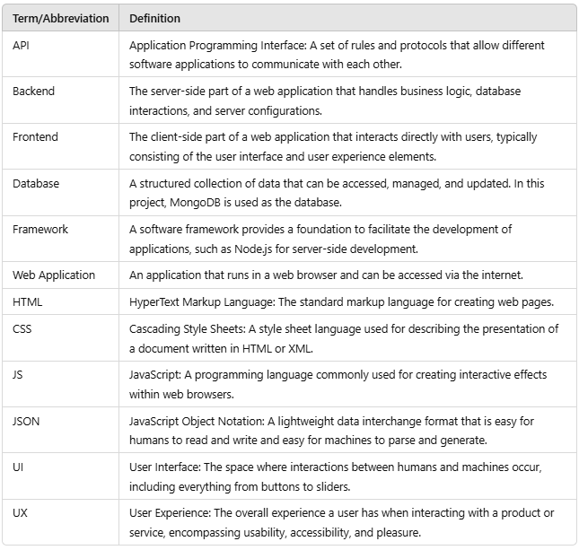

## References [Optional]

**Oracle.** (nd). [Java](https://www.oracle.com/java/technologies/javase/codeconventions-contents.html) Code Conventions . Truy xuất từ [​​https ://www .oracle.com /java /technologies /javase /codeconventions -contents .html](https://www.oracle.com/java/technologies/javase/codeconventions-contents.html)

**Google.** ( nd ). Google JavaScript Style Guide . Truy xuất từ ​​<https://google.github.io/styleguide/jsguide.html>

**MongoDB.** (nd). Tài liệu MongoDB . Truy xuất từ [​​https ://docs .mongodb .com/](https://docs.mongodb.com/)

**W3Schools.** (nd). Hướng dẫn CSS . Lấy từ https ://www .w3schools .com /css/

## Others<Optional>